Edison All Settings
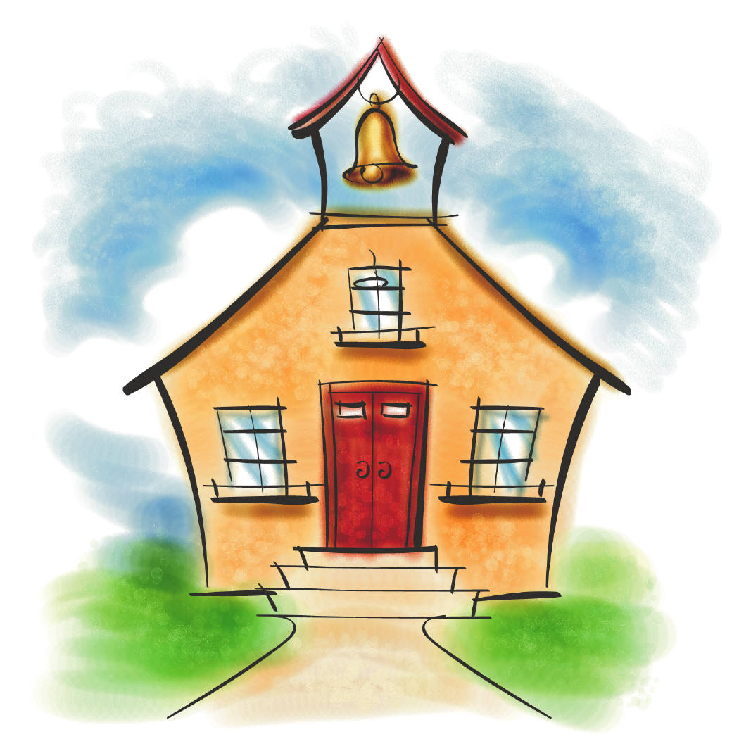
Expectations

Be Safe | Be Respectful | Be Responsible
- Keep hands, feet & objects to self | - Speak and listen using kind words and actions | - Follow all directions given by adults

Trustworthiness~Respect~Responsibility~Fairness~Caring~Citizenship
Arrival/Dismissal
Expectations

Be Safe | Be Respectful | Be Responsible
- Walk  - Take the most direct route to your destination | - Go to the end of the line when lining up | - Arrive on time  - Exit with your class

Trustworthiness~Respect~Responsibility~Fairness~Caring~Citizenship
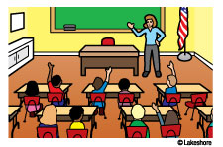Classroom
Expectations
Be Safe | Be Respectful | Be Responsible
- Stay in assigned area | - Raise your hand to speak & wait to be called on | - Complete assignments during given time
 | - Focus on your own learning

Trustworthiness~Respect~Responsibility~Fairness~Caring~Citizenship
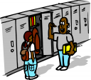
Hallway
Expectations

Be Safe | Be Respectful | Be Responsible
- Walk quietly | - Hands at your side | - Take the most direct route to your destination
- Keep your eyes forward

Trustworthiness~Respect~Responsibility~Fairness~Caring~Citizenship
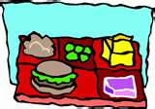
Cafeteria
Expectations
Be Safe | Be Respectful | Be Responsible
- Only eat your own food | - Use your inside voice | - Be in ABC order
- Remain seated and ask permission before getting up | - Use good manners with all people | - Clean up after yourself

Trustworthiness~Respect~Responsibility~Fairness~Caring~Citizenship
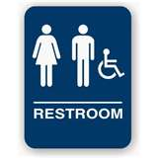
Restroom
Expectations

Be Safe | Be Respectful | Be Responsible
- Wash your hands with soap | - Clean up after yourself | - Report problems to staff
- Respect other’s privacy | - Wait your turn
Trustworthiness~Respect~Responsibility~Fairness~Caring~Citizenship

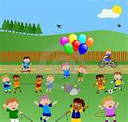
Playground
Expectations
Be Safe | Be Respectful | Be Responsible
- Use equipment as taught | - Take turns | - Bring equipment in after recess
- Leave sand, rocks & snow on the ground | - Play by the rules

Trustworthiness~Respect~Responsibility~Fairness~Caring~Citizenship

